**Name: Yash Jain**

**Assignment 1**

1. **Assign your Name to variable name and Age to variable age. Make a Python program that prints your name and age.**

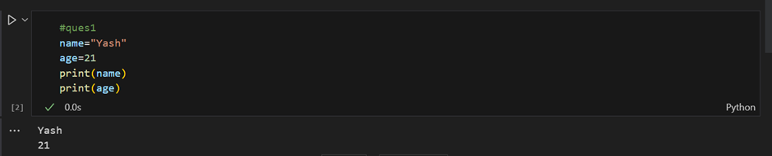

1. **X="Datascience is used to extract meaningful insights."Split the string**

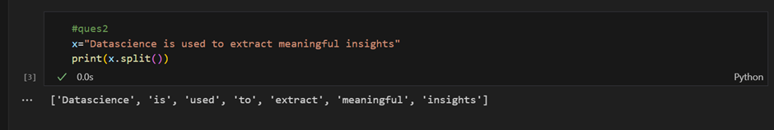

1. **Make a function that gives multiplication of two numbers**

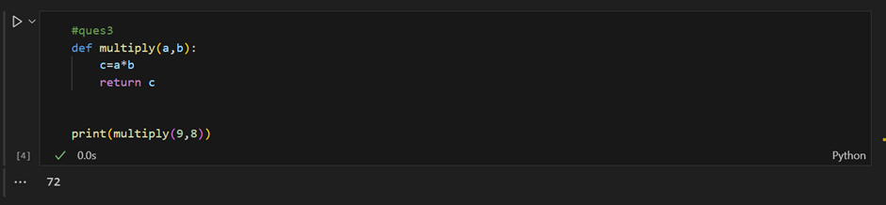

1. **Create a Dictionary of 5 States with their capitals. also print the keys and values.**

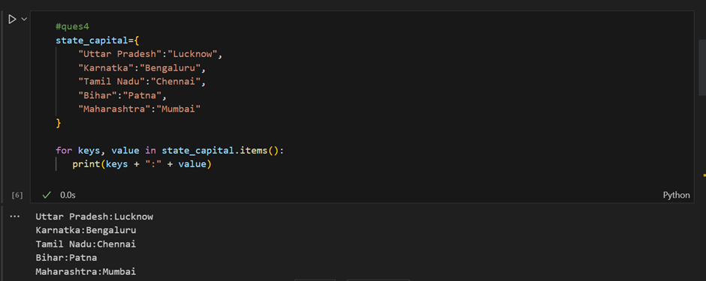

1. **Create a list of 1000 numbers using range function.**

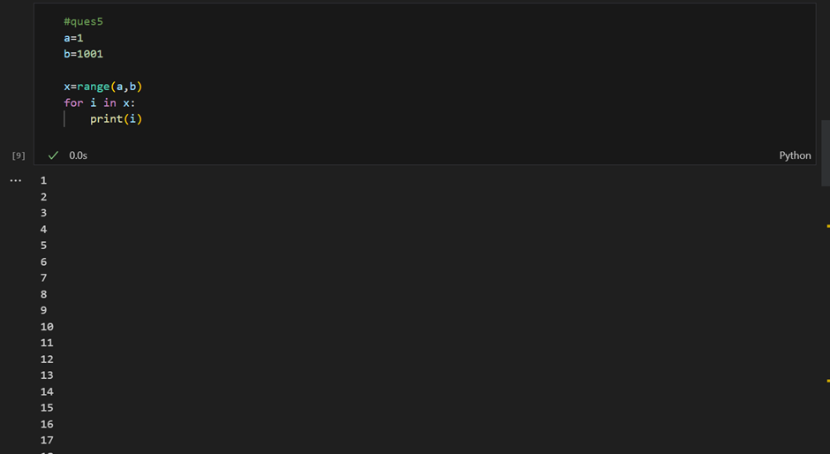

1. **Create an identity matrix of dimension 4 by 4**

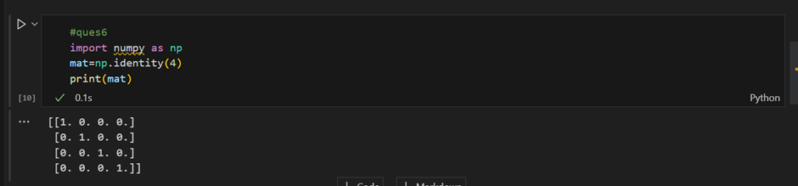

1. **Create a 3x3 matrix with values ranging from 1 to 9**

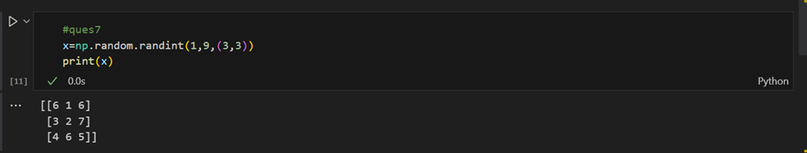

1. **Create 2 similar dimensional array and perform sum on them.**

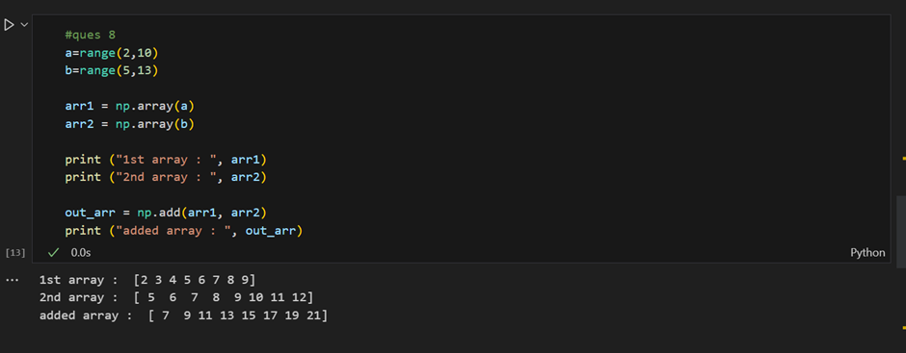

1. **Generate the series of dates from 1st Feb, 2023 to 1st March, 2023 (both inclusive)**

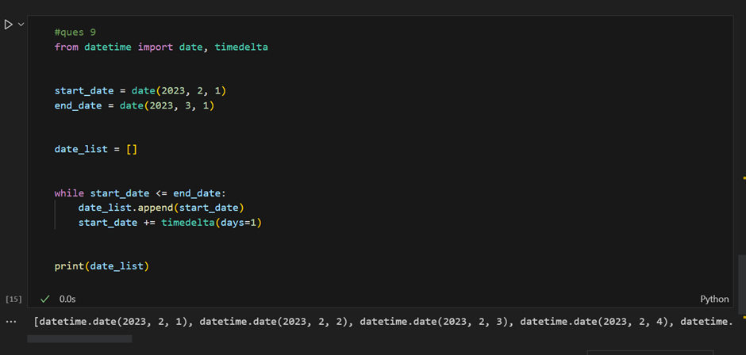

1. **Given a dictionary, convert it into corresponding dataframe and display it .dictionary = {'Brand': ['Maruti', 'Renault', 'Hyndai'], 'Sales' : [250, 200, 240]}**

